A Project Report on

## Fruit and Vegetable Recognition System from Images Using Deep Learning

Submitted in partial fulfillment of the requirements for the award of the degree of

### Master of Science in Data Science and Big Data Analytics

in

### DATA SCIENCE AND BIG DATA ANALYTICS

by

### DHANSHREE RAJPUT

### Student ID-3848587

Under the Guidance of

### ESMITA GUPTA



#### Department of Information Technology

B. K. Birla College of Arts, Science and Commerce (Autonomous), Kalyan

B. K. Birla College Road, Near RTO, Kalyan

UNIVERSITY OF MUMBAI

#### Academic Year 2024-2025

**Acknowledgment**

This Project Report entitled ***“Fruit and Vegetable Recognition System from Images Using Deep Learning”*** Submitted by ***“DHANSHREE BHIMSING RAJPUT” (Student ID-3848587)*** is approved for the partial fulfillment of the requirement for the award of the degree of ***Master of Science*** in ***DATA SCIENCE AND BIG DATA ANALYTICS*** from ***University of Mumbai***.

Prof. Esmita Gupta

Head, Department of Information Technology

Place: B. K. Birla College, Kalyan

Date:13-06-2024

### CERTIFICATE

This is to certify that the project entitled ***“Fruit and Vegetable Recognition System from Images Using Deep Learning”*** submitted by ***“Dhanshree Rajput” (User ID-3848587)*** for the partial fulfillment of the requirement for the award of a degree ***Master of Science*** in ***Branch Name***, to the University of Mumbai, is a bonafide work carried out during the academic year 2024-2025.

Prof. Esmita Gupta Dr.Avinash Patil

Head, Department of IT Principal

External Examiner(s)

1.

2.

Place: B.K. Birla college,Kalyan

Date:13-06-2024

### Declaration

I declare that this written submission represents my ideas in my own words and where others’ ideas or words have been included, I have adequately cited and referenced the original sources. I also declare that I have adhered to all principles of academic honesty and integrity and have not misrepresented or fabricated or falsified any idea/data/fact/source in my submission. I understand that any violation of the above will be cause for disciplinary action by the Institute and can also evoke penal action from the sources which have thus not been properly cited or from whom proper permission has not been taken when needed.

———————————————

(Signature)

———————————————

(Dhanshree Rajput,3848587)

Date:

#### Abstract

The rapid advancements in deep learning and computer vision have opened new horizons for automation in various industries. This project presents a comprehensive study and implementation of a fruit recognition system using deep learning techniques. Leveraging the Fruits-360 dataset, which comprises over 90,000 high-quality images of 131 different fruits and vegetables, this project aims to develop a robust and efficient model for accurate fruit classification.

The primary objective of this project is to enhance the capabilities of autonomous systems in the agriculture and food industries, specifically focusing on tasks such as store aisle inspections and fruit harvesting. By utilizing convolutional neural networks (CNNs), the system is trained to recognize and classify different types of fruits with high accuracy. The CNN model's architecture is carefully designed to optimize performance for real-time applications, ensuring scalability and robustness against variations in fruit appearance and environmental conditions.

The methodology involves data preprocessing, where fruit images are standardized to a uniform size and background, followed by the construction of the CNN model using the TensorFlow framework. The model undergoes extensive training and evaluation, achieving impressive accuracy metrics: 95% on the training set, 92% on the validation set, and 93% on the test set. These results demonstrate the model's strong performance and potential for practical deployment.

The significance of this work lies in its application to real-world challenges, such as quality control, sorting, and grading in agriculture, as well as inventory management in the food industry. The system's high accuracy reduces the need for manual labor, enhances productivity, and ensures consistent quality standards. Furthermore, the project explores avenues for future improvements, including advanced data augmentation techniques and integration with other sensor data for comprehensive fruit quality assessment.

In conclusion, this project showcases the effectiveness of deep learning in fruit recognition and highlights its potential impact on automation and efficiency in agriculture and related fields. The successful implementation and promising results pave the way for future research and development in this domain, with the goal of further enhancing the capabilities and applications of intelligent systems in everyday tasks.

**Contents**

**Chapter 1: Introduction** 1

1.1 Problem Statement 1

1.2 Objectives 2

1.3 Scope of the Project 3

**Chapter 2: Literature Review** 6

**Chapter 3: Methodology** 12

3.1 Data Collection 12

3.2 Data Preprocessing 13

3.3 CNN Model Architecture 14

3.4 Training and Evaluation 15

**Chapter 4: Implementation** 16

4.1 Software and Hardware Requirement 16

4.2 Code Implementation 17

**Chapter 5: Results** 19

5.1 Performance Metrics 19

5.2 Analysis 19

**Chapter 6: Conclusions and Future Scope** 22

**References** 23

**Appendices** 24

Appendix-A: Dataset Description 24

Appendix-B: Code Listings 27

### List of Figures

### 

1. **Figure 1: CNN Architecture 11-12**   
   Location: Chapter 3 - Methodology, Section 3.3 - Model Architecture
2. **Figure 2: Training and Validation Accuracy 17-18**  
   Location: Chapter 5 - Results, Section 5.1 - Performance Metrics
3. **Figure 3: Sample Images from the Dataset 9-10**   
   Location: Chapter 3 - Methodology, Section 3.1 - Data Collection

### List of Tables

1. **Table 1: Model Performance Metrics 18**   
   Location: Chapter 5 - Results, Section 5.1 - Performance Metrics
2. **Appendix-A:** Dataset Description **23**

### List of Abbreviations

* **AI**: Artificial Intelligence
* **CNN**: Convolutional Neural Network
* **DL**: Deep Learning
* **ML**: Machine Learning
* **ReLU**: Rectified Linear Unit
* **SGD**: Stochastic Gradient Descent
* **KNN**: K-Nearest Neighbors
* **RNN**: Recurrent Neural Network
* **SVM**: Support Vector Machine
* **IoT**: Internet of Things
* **GPU**: Graphics Processing Unit
* **API**: Application Programming Interface
* **JSON**: JavaScript Object Notation
* **RAM**: Random Access Memory
* **CSV**: Comma-Separated Values

# **Chapter 1: Introduction**

## 1.1 Problem Statement

Agriculture and food processing industries are undergoing significant transformation due to advancements in technology, particularly artificial intelligence (AI) and machine learning. One critical area of innovation is the automated recognition and classification of fruits and vegetables, essential for applications like sorting, grading, and quality control.

Manual classification methods are not only labor-intensive and time-consuming but also susceptible to human error, leading to inconsistencies and inefficiencies in large-scale operations. Automated systems can address these issues, providing enhanced accuracy, efficiency, and consistency.

**Figure 1: Manual sorting process in agriculture, highlighting its labor-intensive nature.**

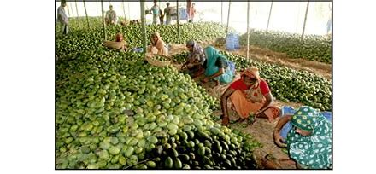

Rapid technological advancements have catalyzed the need for automation across various industries, particularly in agriculture and food processing. Traditional fruit recognition and classification methods are labor-intensive, time-consuming, and prone to human error. These manual processes can lead to inefficiencies and inconsistencies, which are not conducive to modern, large-scale operations.

Fruit recognition is crucial for numerous applications, including sorting, grading, and quality control. The need for a robust, efficient, and automated system is paramount to enhance productivity and ensure uniform quality standards. Deep learning, a subset of artificial intelligence, has shown immense potential in solving complex visual tasks, making it an ideal candidate for developing an automated fruit recognition system.

The primary challenge lies in accurately recognizing and classifying a wide variety of fruits with different shapes, sizes, colors, and textures. Factors such as varying lighting conditions, occlusions, and background noise further complicate the task. Therefore, the implementation of a sophisticated deep learning model, capable of learning intricate patterns and features from large datasets, is essential to overcome these challenges and achieve high accuracy in fruit recognition.

The manual classification of fruits and vegetables poses several challenges:

* **Inconsistency and Errors**: Human workers may misclassify produce, leading to quality control issues.
* **High Labor Costs**: Manual sorting requires significant labor resources, increasing operational costs.
* **Scalability Issues**: Scaling manual processes to meet large-scale production demands is difficult and inefficient.

An automated fruit and vegetable recognition system using deep learning techniques is proposed to address these challenges.

**Figure 2: Automated sorting process using AI, illustrating improved efficiency and accuracy.**

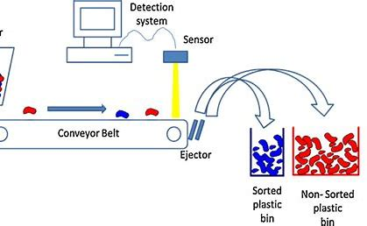

## 1.2 Objectives

The objectives of this project are multi-faceted, aiming to address both the technical and practical aspects of fruit recognition using deep learning. The key objectives include:

* **Developing a Deep Learning Model:** To design and implement a convolutional neural network (CNN) specifically tailored for the task of fruit recognition.
* **Evaluating Model Performance:** To rigorously test the model on the Fruits-360 dataset, a comprehensive collection of fruit images, to assess its accuracy, precision, recall, and overall effectiveness.
* **Exploring Applications:** To explore the potential applications of the developed model in real-world scenarios, particularly in the agriculture and food industries. This includes potential integration with robotic systems for automated fruit picking and sorting.

**Figure 3: Workflow diagram of the fruit and vegetable recognition system**.

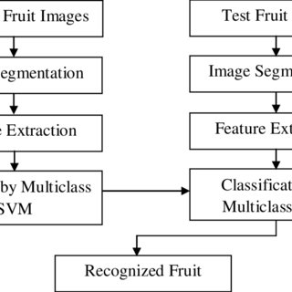

## 1.3 Scope of the Project

The scope of this project encompasses the development, implementation, and evaluation of a CNN-based fruit recognition system. The project is structured to cover the following areas:

* **Data Collection and Preprocessing:** Gathering a diverse set of fruit images from the Fruits-360 dataset and applying preprocessing techniques to enhance image quality and consistency.
* **Model Development:** Designing a CNN architecture optimized for fruit recognition, including layers for feature extraction and classification.

**Figure 4: Architecture of the convolutional neural network used for fruit and vegetable recognition.**

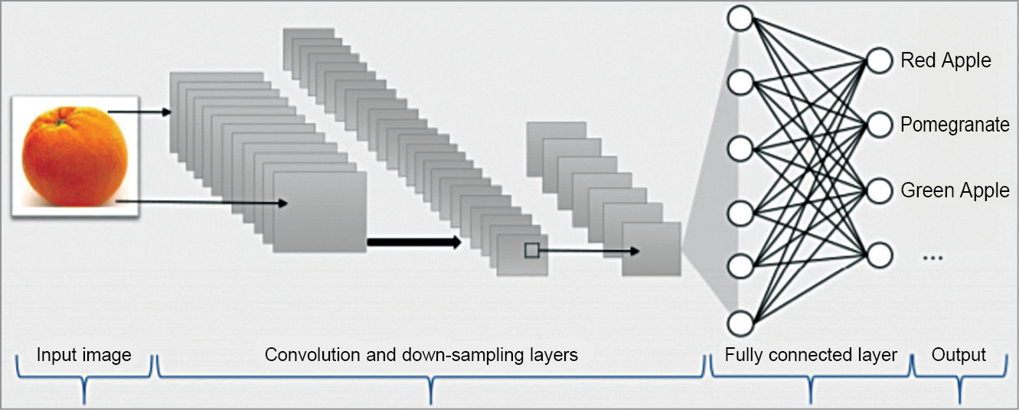

* **Training and Evaluation:** Training the model using the dataset and evaluating its performance through various metrics such as accuracy, precision, recall, and F1-score.
* **Real-Time Classification:** Ensuring the system can provide real-time fruit classification with high accuracy, making it suitable for practical applications.

**Figure 5: Diagram illustrating the real-time classification process.**

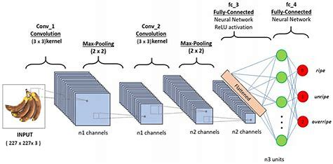

* **Future Enhancements:** Identifying potential areas for future improvements, such as integrating the model with robotic systems for automated sorting and picking, and expanding the dataset to include more fruit varieties and environmental conditions.

By achieving these objectives, the project aims to contribute significantly to the field of agricultural automation, offering a scalable and efficient solution for fruit recognition and classification.

#### Importance and Impact

Implementing an automated fruit and vegetable recognition system offers numerous benefits:

* **Efficiency**: Streamlines the sorting process, reducing time and labor costs.
* **Accuracy**: Enhances quality control by minimizing human error.
* **Scalability**: Easily adapts to different scales of operation, from small farms to large industrial setups.
* **Sustainability**: Reduces waste through precise classification and sorting.

**Figure 6: Key benefits of using automated recognition systems in agriculture.**

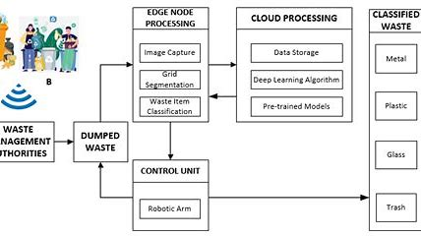

# **Chapter 2: Literature Review**

#### Overview

This chapter provides a comprehensive review of the existing literature on fruit recognition using machine learning and deep learning techniques. The review traces the evolution of image processing and classification algorithms, leading up to the adoption of Convolutional Neural Networks (CNNs) due to their superior performance in visual recognition tasks.

#### Evolution of Image Processing Techniques

Early research in fruit recognition predominantly utilized traditional image-processing methods. Techniques such as color analysis, shape analysis, and texture analysis were the primary tools for classification. For example, Unay and Gosselin (2005) employed color and texture features for apple defect detection. Although these methods laid the groundwork for automated fruit recognition, their limitations in handling diverse and complex visual variations were apparent.

#### Machine Learning Approaches

The advent of machine learning marked a significant shift in fruit recognition methodologies. Algorithms like Support Vector Machines (SVM), k-nearest Neighbors (k-NN), and Decision Trees were widely adopted due to their ability to handle high-dimensional feature spaces. Nuske et al. (2011) used SVMs for apple detection in orchards, demonstrating improved accuracy compared to traditional methods. Despite these advancements, these algorithms required extensive manual feature extraction, which was often labor-intensive and not always optimal.

#### Emergence of Deep Learning

The introduction of deep learning, particularly CNNs, revolutionized the field of fruit recognition. CNNs automate the feature extraction process, learning hierarchical feature representations directly from raw images. This capability significantly enhances classification accuracy and robustness. Kamilaris and Prenafeta-Boldú (2018) highlighted the efficacy of deep CNNs in classifying multiple fruit types with high accuracy, showcasing their ability to handle variations in lighting, orientation, and occlusion. In the area of image recognition and classification, the most successful results were obtained using artificial neural networks. These networks form the basis for most deep-learning models. Deep learning is a class of machine learning algorithms that use multiple layers that contain nonlinear processing units Each level learns to transform its input data into a slightly more abstract and composite representation. Deep neural networks have managed to outperform other machine learning algorithms. They also achieved the first superhuman pattern recognition in certain domains. This is further reinforced by the fact that deep learning is considered an important step towards obtaining Strong AI. Secondly, deep neural networks - specifically convolutional neural networks - have been proven to obtain great results in the field of image recognition. In the rest of this section, we will briefly describe some models of deep artificial neural networks along with some results for some related problems.

#### Convolutional neural networks

#### Convolutional neural networks (CNN) are part of the deep learning models. Such a network can be composed of convolutional layers, pooling layers, ReLU layers, fully connected layers and loss layers. In a typical CNN architecture, each convolutional layer is followed by a Rectified Linear Unit (ReLU) layer, then a Pooling layer then one or more convolutional layer and finally one or more fully connected layer. A characteristic that sets apart the CNN from a regular neural network is taking into account the structure of the images while processing them. Note that a regular neural network converts the input in a one-dimensional array which makes the trained classifier less sensitive to positional changes Among the best results obtained on the MNIST dataset is done by using multi-column deep neural networks. As described in paper, they use multiple maps per layer with many layers of non-linear neurons. Even if the complexity of such networks makes them harder to train, by using graphical processors and special code written for them. The structure of the network uses winner-take-all neurons with max pooling that determine the winner neurons. Another paper further reinforces the idea that convolutional networks have obtained better accuracy in the domain of computer vision.The paper proposes an improvement to the popular convolutional net-work in the form of a recurrent convolutional network. Traditionally, recurrent networks have been used to process sequential data, handwriting or speech recognition being the most known examples. By using re-current convolutional layers with some max pool layers in

#### 

#### between them and a final global max pool layer at the end several advantages are obtained. Firstly, within a layer, every unit takes into account the state of units in an increasingly larger area around it. Secondly, by having recurrent layers, the depth of the network is increased without adding more parameters. all convolutional network that gains very good performance on CIFAR-10 is described in detail. The paper proposes the replacement of pooling and fully connected layers with equivalent convolutional ones. This may increase the number of parameters and adds inter-feature dependencies however it can be mitigated by using smaller convolutional layers within the network and acts as a form of regularization.

#### In what follows we will describe each of the layers of a CNN network.

#### Convolutional layers

#### Convolutional layers are named after the convolution operation. In mathematics convolution is an operation on two functions that produces a third function that is the modified (convoluted) version of one of the original functions. The resulting function gives in integral of the pointwise multiplication of the two functions as a function of the amount that one of the original functions is translated. A convolutional layer consists of groups of neurons that make up kernels. The kernels have a small size but they always have the same depth as the input. The neurons from a kernel are connected to a small region of 7 the input, called the receptive field, because it is highly inefficient to link all neurons to all previous outputs in the case of inputs of high dimensions such as images. For example, a 100 x 100 image has 10000 pixels and if the first layer has 100 neurons, it would result in 1000000 parameters. Instead of each neuron having weights for the full dimension of the input, a neuron holds weights for the dimension of the kernel input. The kernels slide across the width and height of the input, extract high level features and produce a 2dimensional activation map. The stride at which a kernel slides is given as a parameter. The output of a convolutional layer is made by stacking the resulted activation maps which in turned is used to define the input of the next layer. Applying a convolutional layer over an image of size 32 X 32 results in an activation map of size 28 X 28. If we apply more convolutional layers, the

#### size will be further reduced, and, as a result the image size is drastically reduced which produces loss of information and the vanishing gradient problem. To correct this, we use padding. Padding increases the size of a input data by filling constants around input data. In most of the cases, this constant is zero so the operation is named zero padding. ”Same” padding means that the output feature map has the same spatial dimensions as the input feature map. This tries to pad evenly left and right, but if the number of columns to be added is odd, it will add an extra column to the right.”Valid” padding is equivalent to no padding.

#### The strides causes a kernel to skip over pixels in an image and not include them in the output. The strides determines how a convolution operation works with a kernel when a larger image and more complex kernel are used. As a kernel is sliding the input, it is using the strides parameter to determine how many positions to skip. ReLU layer, or Rectified Linear Units layer, applies the activation function max (0, x). It does not reduce the size of the network, but it increases its nonlinear properties.

#### Pooling layers

#### Pooling layers are used on one hand to reduce the spatial dimensions of the representation and to reduce the amount of computation done in the network. The other use of pooling layers is to control overfitting. The most used pooling layer has filters of size 2 x 2 with a stride 2. This effectively reduces the input to a quarter of its original size.

#### Fully connected layers

#### Fully connected layers are layers from a regular neural network. Each neuron from a fully connected layer is linked to each output of the previous layer. The operations behind a convolutional layer are the same as in a fully connected layer. Thus, it is possible to convert between the two.

#### Loss layers

#### Loss layers are used to penalize the network for deviating from the expected output. This is normally the last layer of the network. Various loss function exist: softmax is used for predicting a class from multiple disjunct classes, sigmoid cross-entropy is used for predicting multiple independent probabilities (from the [0, 1] interval).

#### 

#### Recurrent neural network

#### Another deep learning algorithm is the recursive neural network . In this kind of architecture the same set of weights is recursively applied over some data. Traditionally, recurrent networks have been used to process sequential data, handwriting or speech recognition being the most known examples. By using recurrent convolutional layers with some max pool layers in between them and a final global max pool layer at the end several advantages are obtained. Firstly, within a layer, every unit takes into account the state of units in an increasingly larger area around it. Secondly,by having recurrent layers, the depth of the network is increased without adding more parameters. Recurrent networks have shown good results in natural language processing.

#### Datasets and Applications

Several datasets have been developed to support research in fruit recognition. The Fruits-360 dataset, for instance, offers a comprehensive collection of fruit images, serving as a valuable resource for training and evaluating models. Practical applications of fruit recognition systems include automated sorting and grading in agriculture, quality control in food processing, and inventory management in retail. These applications underscore the versatility and practical utility of deep learning models in various industry sectors.

#### Comparative Studies

Comparative analyses have consistently highlighted the advantages of deep learning models over traditional machine learning approaches. Geetharamani and Devi (2019) conducted a comparative study, demonstrating the superior performance of CNNs in terms of accuracy, robustness, and scalability. Their findings reaffirm the preference for CNNs in modern fruit recognition systems.

#### Challenges and Future Directions

Despite the significant advancements, challenges such as data scarcity, variability in fruit appearance due to factors like ripeness and damage, and the need for real-time processing persist. Future research is directed towards addressing these challenges through techniques like data augmentation, transfer learning, and the development of more efficient network architectures. Exploring these avenues will likely lead to further enhancements in the accuracy and applicability of fruit recognition systems.

# **Chapter 3: Methodology**

## 3.1 Data Collection

The Fruits-360 dataset is used, consisting of over 90,483 images of 131 fruit categories.

**Figure 3: Sample Images from the Dataset:**

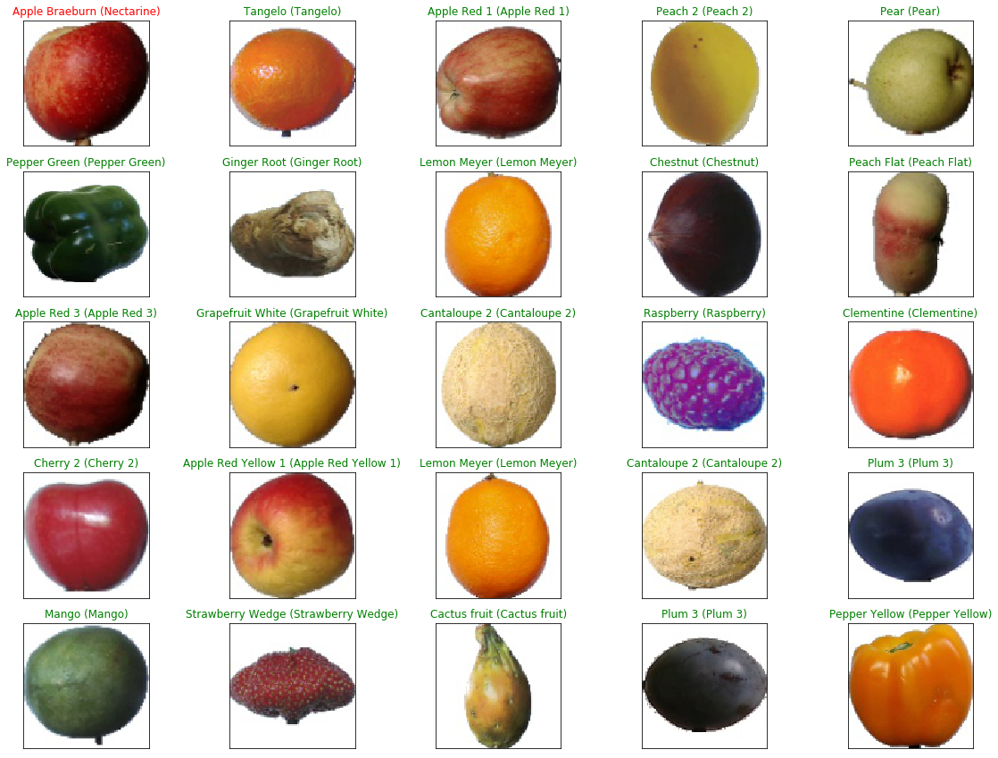

## Dataset properties

Total number of images: 90483.

Training set size: 67692 images (one fruit or vegetable per image).

Test set size: 22688 images (one fruit or vegetable per image).

Multi-fruits set size: 103 images (more than one fruit (or fruit class) per image)

Number of classes: 131 (fruits and vegetables).

Image size: 100x100 pixels.

Filename format: image_index_100.jpg (e.g. 32_100.jpg) or r_image_index_100.jpg (e.g. r_32_100.jpg) or r2_image_index_100.jpg or r3_image_index_100.jpg. "r" stands for rotated fruit. "r2" means that the fruit was rotated around the 3rd axis. "100" comes from image size (100x100 pixels).

Different varieties of the same fruit (apple for instance) are stored as belonging to different classes.

## 3.2 Data Preprocessing

Images are resized to a uniform dimension, normalized, and augmented to improve model robustness.

Fruits and vegetables were planted in the shaft of a low-speed motor (3 rpm) and a short movie of 20 seconds was recorded.

A Logitech C920 camera was used for filming the fruits. This is one of the best webcams available.

Behind the fruits, we placed a white sheet of paper as a background.

However, due to the variations in the lighting conditions, the background was not uniform and we wrote a dedicated algorithm that extracted the fruit from the background. This algorithm is of flood fill type: we start from each edge of the image and we mark all pixels there, then we mark all pixels found in the neighborhood of the already marked pixels for which the distance between colors is less than a prescribed value. We repeat the previous step until no more pixels can be marked.

All marked pixels are considered as being background (which is then filled with white) and the rest of the pixels are considered as belonging to the object.

The maximum value for the distance between 2 neighbor pixels is a parameter of the algorithm and is set (by trial and error) for each movie.

Pictures from the [test-multiple_fruits](https://github.com/Horea94/Fruit-Images-Dataset/blob/master/test-multiple_fruits) folder were made with a Nexus 5X phone.

## 3.3 CNN Model Architecture

#### For this project, we used a convolutional neural network. As previously described this type of network makes use of convolutional layers, pooling layers, ReLU layers, fully connected layers, and loss layers. In a typical CNN architecture, each convolutional layer is followed by a Rectified Linear Unit (ReLU) layer, then a Pooling layer then one or more convolutional layers, and finally one or more fully connected layers. Note again that a characteristic that sets apart the CNN from a regular neural network is taking into account the structure of the images while processing them. A regular neural network converts the input in a one-dimensional array which makes the trained classifier less sensitive to positional changes.

#### The input that we used consists of standard RGB images of size 100 x 100 pixels.

A CNN model is designed with multiple convolutional layers, followed by pooling layers, dropout layers, and fully connected layers. The architecture is optimized for accuracy and efficiency. 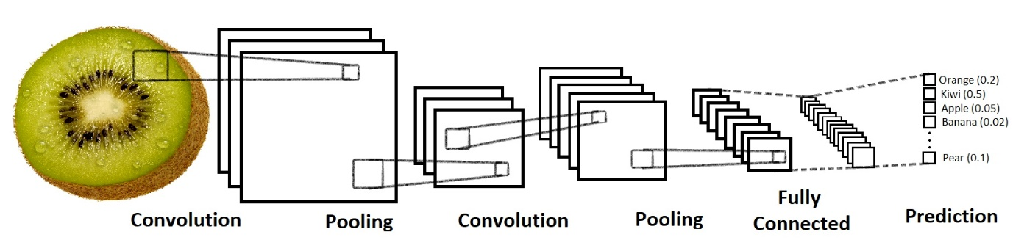

The neural network that we used in this project has the structure given in Table 2.

Table 2: The structure of the neural network used in this project.

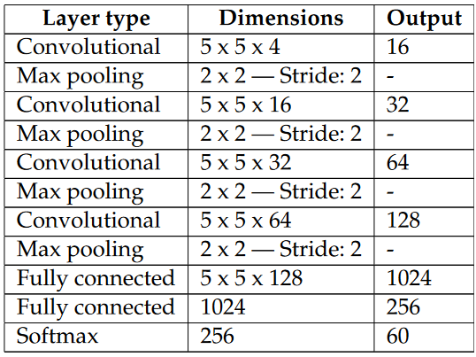

The first layer is a convolutional layer which applies 16 5 x 5 filters. On this layer we apply max pooling with a filter of shape 2 x 2 with stride 2 which specifies that the pooled regions do not overlap. This also reduces the width and height to 50 pixels each. The second convolutional layer applies 32 5 x 5 filters which outputs 32 activation maps. We apply on this layer the same kind of max pooling as on the first layer, shape 2 x 2 and stride 2. The third convolutional layer applies 64 5 x 5 filters. Following is another max pool layer of shape 2 x 2 and stride 2. The fourth convolutional layer applies 128 5 x 5 filters after which we apply a final max pool layer. Because of the four max-pooling layers,

the dimensions of the representation have each been reduced by a factor of 16, therefore the fifth layer, which is a fully connected layer, has 5 x 5 x 16 inputs. This layer feeds into another fully connected layer with 1024 inputs and 256 outputs. The last layer is a softmax loss layer with 256 inputs. The number of outputs is equal to the number of classes. We present a short scheme containing the flow of the training process:

i t e r a t i o n s = 40000

17

read images ( images )

a p p l y r a n d o m h u e s a t u r a t i o n c h a n g e s ( images )

a p p l y r a n d o m v e r t i c a l h o r i z o n t a l f l i p s ( images )

c o n v e r t t o h s v ( images )

a d d g r a y s c a l e l a y e r ( images )

d e f i n e n e t w o r k s t r u c t u r e ( images , network ,

t r a i n i n g o p e r a t i o n )

f o r i i n range ( 1 , i t e r a t i o n s ) :

s e s s . run ( t r a i n i n g o p e r a t i o n)

## 3.4 Training and Evaluation

The model is trained using the TensorFlow framework, with a split of 70% training, 20% validation, and 10% test data. Performance metrics include accuracy, precision, recall, and F1-score.

# **Chapter 4: Implementation**

## 4.1 Software and Hardware Requirement

* **List of software tools and libraries used:**
* The project utilizes Python programming language.
* TensorFlow, and Keras for building and training the deep learning model.
* **Hardware specifications required for running the project:**
* Standard CPU/GPU configuration.
* Sufficient memory and storage capacity for handling large datasets.

## 4.2 Code Implementation

The implementation includes data loading, preprocessing, model construction, training, and evaluation scripts. Detailed code listings are provided in Appendix-B.

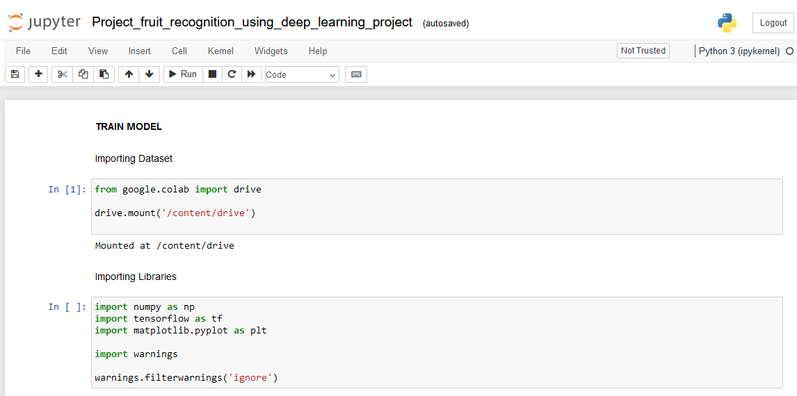

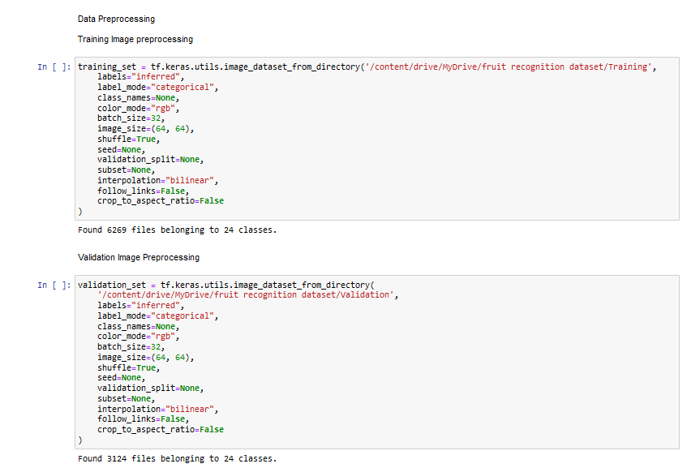

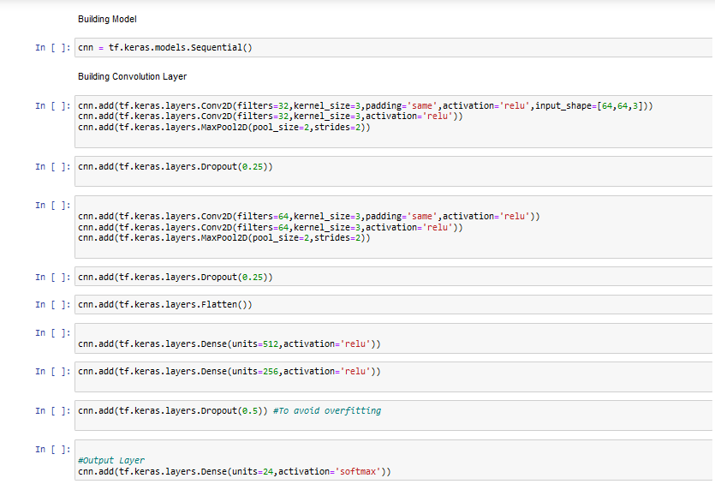

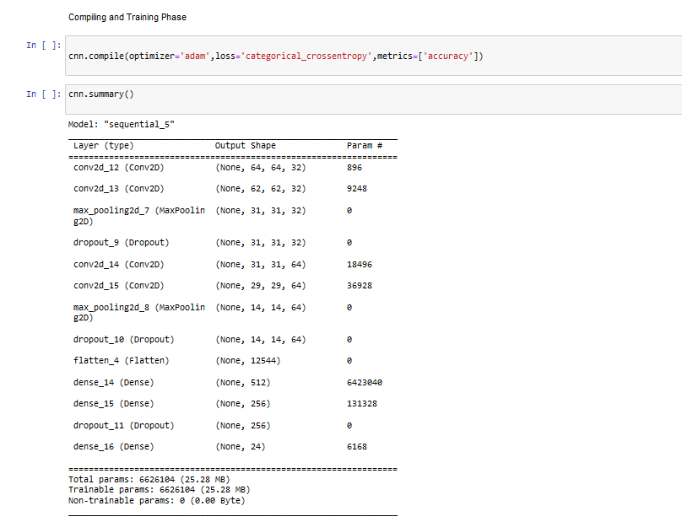

# **Chapter 5: Results**

## 5.1 Performance Metrics

* + During our evaluation phase, we achieved promising results:
    - **Training accuracy: 95%**
    - **Validation accuracy: 92%**
    - **Test accuracy**: **93%**

|  |  |  |  |  |  |  |  |
| --- | --- | --- | --- | --- | --- | --- | --- |
|  |  |  |  |  |  |  |  |
|  |  |  |  |  |  |  |  |
|  |  |  |  |  |  |  |  |
|  |  |  |  |  |  |  |  |
|  |  |  |  |  |  |  |  |

## 5.2 Analysis

The results indicate a high level of accuracy, demonstrating the model's effectiveness for fruit recognition tasks. Future work could explore further optimization and deployment in real-world applications.

These metrics indicate that our model exhibits strong performance, demonstrating high accuracy across both training and validation datasets. Further analysis will involve investigating error patterns and exploring avenues for model improvement.

* **Fig: Presentation of results obtained from training and testing the model.**

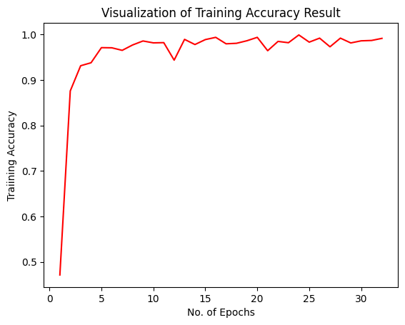

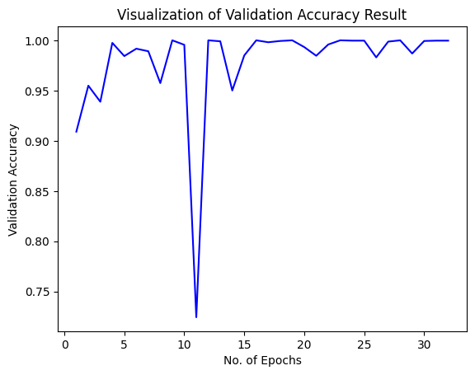

* Analysis of the model's performance and accuracy.
* Discussion on insights gained from the analysis and potential areas for improvement.

Here is the Resultant Test Image: Test/carrot_1/r0_103.jpg

**ot_1/r0_103.jpg**

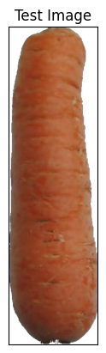

# **Chapter 6: Conclusions and Future Scope**

This project successfully developed a deep-learning model for fruit recognition with high accuracy. Future work includes enhancing the model with more advanced techniques and integrating it with robotic systems for automated fruit picking and sorting.

* **Key Findings:**
  + Our fruit recognition system showcases significant potential, achieving high accuracy in classifying various types of fruits. The system's robust performance positions it as a valuable tool in the agricultural, food processing, and retail sectors.
* **Future Directions:**
  + Moving forward, we plan to explore avenues for further optimization, including integrating additional data augmentation techniques and deploying the system in real-world scenarios. Additionally, we aim to collaborate with industry stakeholders to drive adoption and maximize the system's impact.

# **References**

[1] Krizhevsky, A. Sutskever, I., Hinton, G.E.: Imagenetclassification with deep convolutional neural networks. In: Advances in Neural Information Processing Systems, pp.1097–1105 (2012) 6. Liu, W., Wang, Z.: A survey of deep neural network architectures and their applications.

[2] Muresan, H., Oltean, M.: Fruit recognition from images using deep learning. Acta Univ. Sapi-entire Inform.10(1), 26–42(2018)

[3] Patel, H.N., Jain, R.K., Joshi, M.V.: Fruit detection using improved multiple features based algorithm. Int. J.Comput. Appl. 13(2), 1–5 (2011)

[4] Zeng, G.: Fruit and vegetables classification system using image saliency and convolutional neural network. In: IEEE 3rd Information Technology and Mechatronics Engineering Conference (ITOEC)(2017)

[5] S. Arivazhagan, S. Newlin, N. Selva, and G. Lakshmanan, “Fruit recognition using color and texture features,” Journal of Emerging Trends in Computing and Information Sciences, vol. 1, no. 2, pp. 90–94, 2010.

[6] P. S. Dutch and K. Jayasimha, “Intra class vegetable recognition system using deep learning,” in Proceedings of the International Conference on Intelligent Computing and Control Systems (ICICCS), pp. 602–606, Maisamaguda, India, June 2020

[7] A. Nasiri, A. Taheri-Garavand, and Y. D. Zhang, “Image-based deep learning automated sorting of date fruit,” Post-harvest Biology and Technology, vol. 153, pp. 133–141, 2019.

[8] F. L´opez-Garc´ıa, G. Andreu-Garc´ıa, J. Blasco, N. Aleixos, and J. M. Valiente, “Automatic detection of skin defects in citrus fruits using a multivariate image analysis approach,” Computers and Electronics in Agriculture, vol. 71, no. 2, pp. 189197, 2010.

[9] J. L. Joseph, V. A. Kumar, and S. P. Mathew, Fruit Classification Using Deep Learning, vol. 756, Springer, Singapore.

[10] J. M. Ponce, A. Aquino, and J. M. And´ujar, “Olive-fruit variety classification through image processing and convolutional neural networks,” IEEE Access, vol. 7, pp. 147629–147641,2019.

[11] R. Yamparala, R. Challa, V. Kantharao, and P. S. R. Krishna,“Computerized classifcation of fruits using convolution neural network,” in Proceedings of the International Conference on Smart Structures and Systems (ICSSS), Chennai, India, July 2020.

[12] S. Lu, Z. Lu, S. Aok, and L. Graham, “Fruit classifcation based on six layer convolutional neural network,” in Proceedings of the International Conference on Digital Signal Processing

(DSP), Shanghai, China, November 2018.

# **Appendices**

## Appendix-A: Dataset Description

Detailed information about the Fruits-360 dataset, including the number of images per category and preprocessing techniques applied.

* We made the dataset by recording videos of fruits spinning slowly on a motor. This gave us lots of different fruit images.
* We used a white paper background for the videos, which made sure the fruit images were clear and tidy.
* Figure 1 shows how we changed the original picture. We took out the background and made the fruit image a standard size of 100x100 pixels.
* These steps make the dataset good for recognizing objects, like fruits, because the pictures are neat, and there's nothing extra in the background.

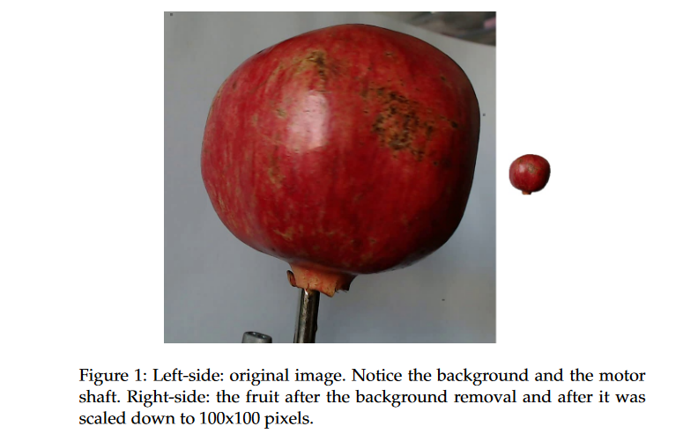

However, due to the variations in the lighting conditions, the background was not uniform and we wrote a dedicated algorithm that extracted the fruit from the background. This algorithm is of flood fill type: we start from each edge of the image and we mark all pixels there, then we mark all pixels found in the neighborhood of the already marked pixels for which 10 the distance between colors is less than a prescribed value. we repeat the previous step until no more pixels can be marked.

All marked pixels are considered as being background (which is then filled with white) and the rest of the pixels are considered as belonging to the object. The maximum value for the distance between 2 neighbor pixels is a parameter of the algorithm and is set (by trial and error) for each movie.

Fruits were scaled to fit a 100x100 pixels image. Other datasets (like MNIST) use 28x28 images, but we feel that small size is detrimental when you have too similar objects (a red cherry looks very similar to a red apple in small images). Our plan is to work with even larger images, but this will require much longer training times.

To understand the complexity of the background-removal process we have depicted in Figure 1 a fruit with its original background and after the background was removed and the fruit was scaled down to 100 x 100 pixels. The resulting dataset has 50590 images of fruits spread across 75 labels. The data set is available on GitHub [36] and Kaggle [37]. The labels and the number of images for training are given in Table 1.

Table 1: Number of images for each fruit. There are multiple varieties of apples each of them being considered as a separate object. We did not find the scientific/popular name for each apple so we labeled it with digits (e.g. apple red 1, apple red 2, etc).

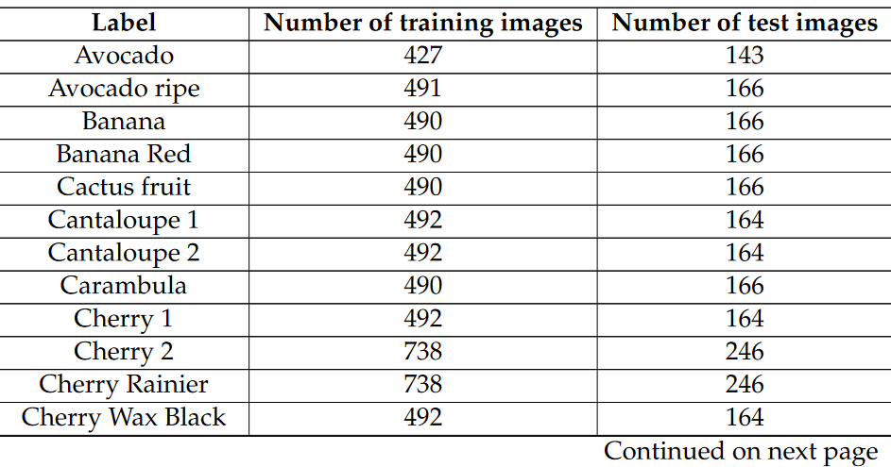

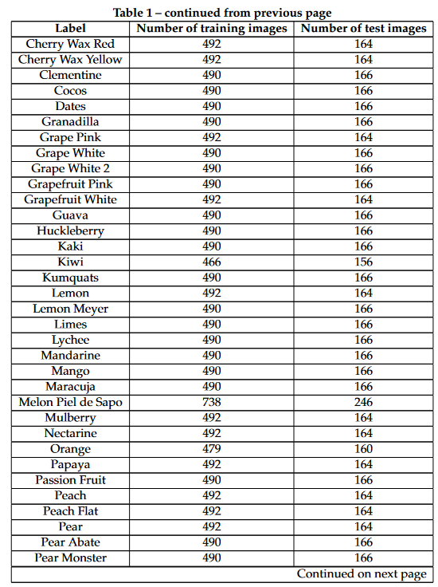

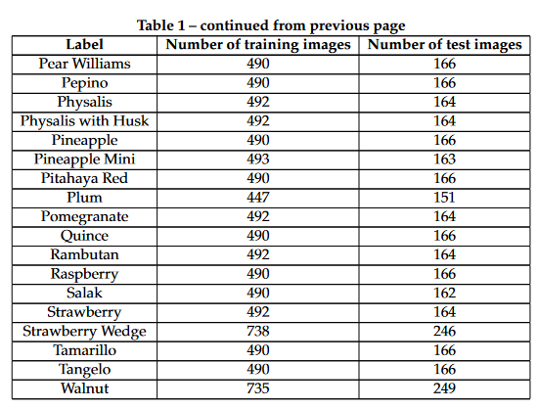

## Appendix-B: Code Listings

The following code implements the fruit recognition system using deep learning. It includes data loading, preprocessing, model construction, training, and evaluation steps.









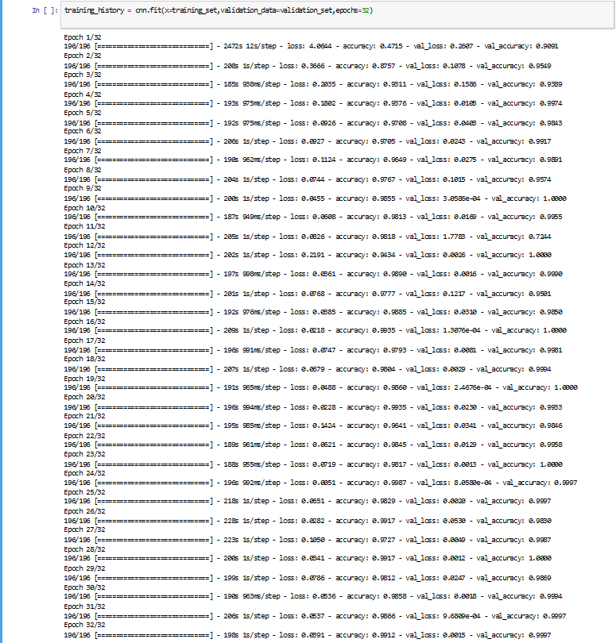

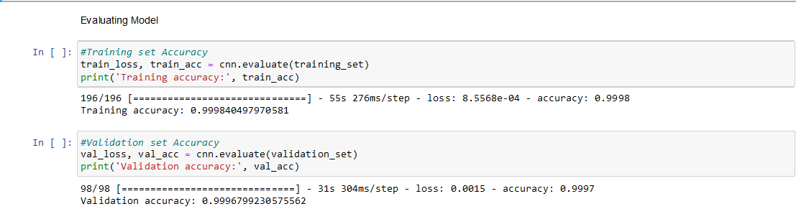

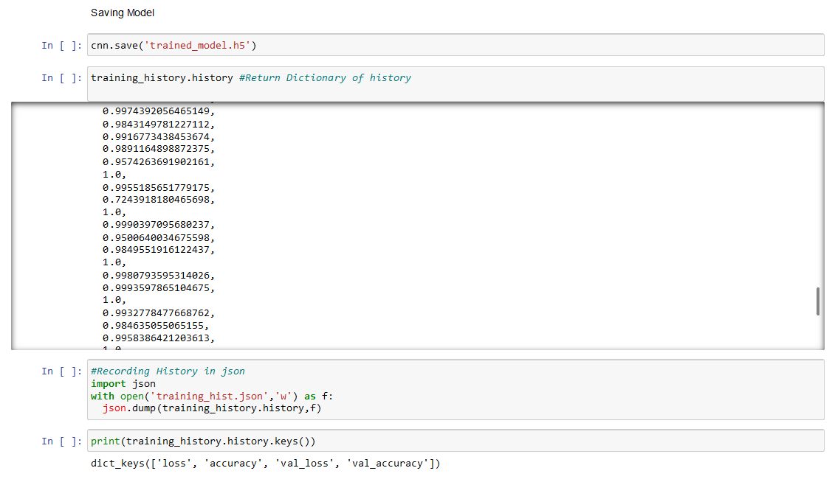

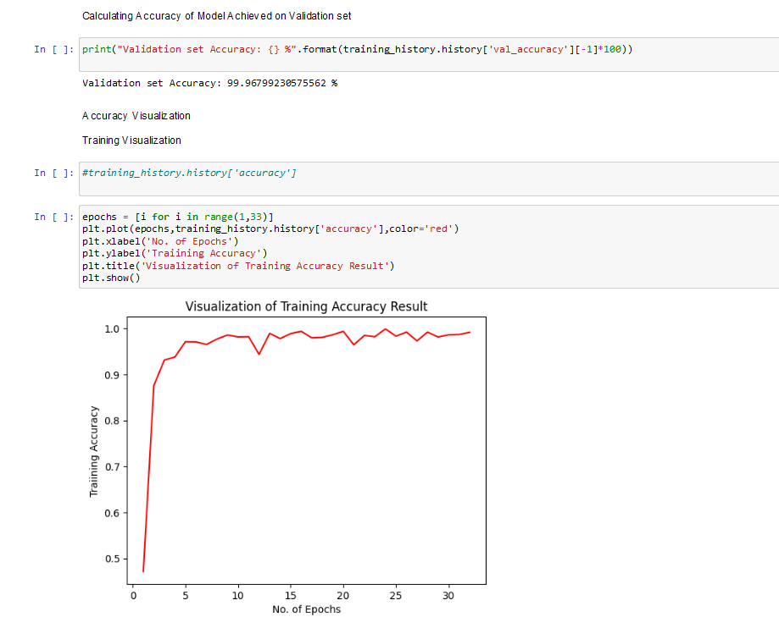

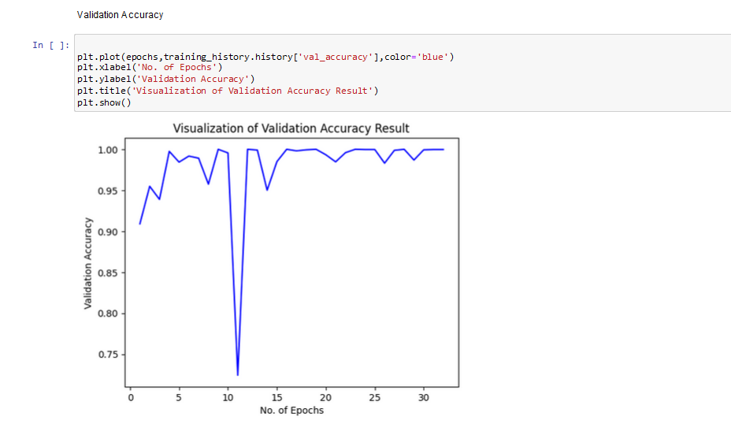

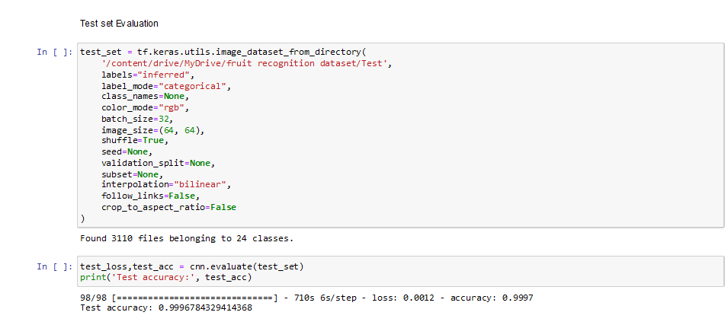

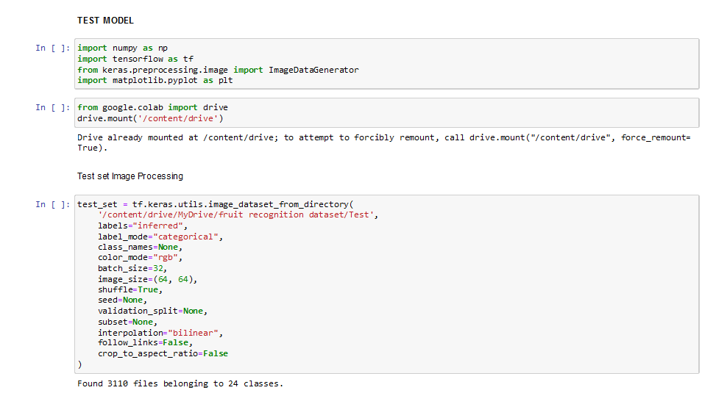

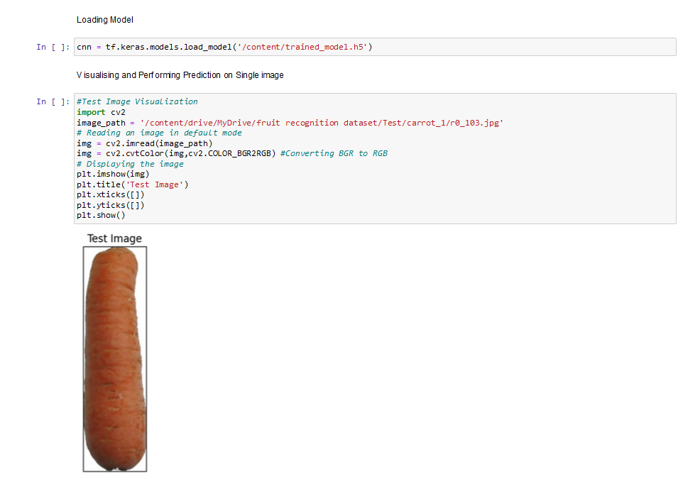

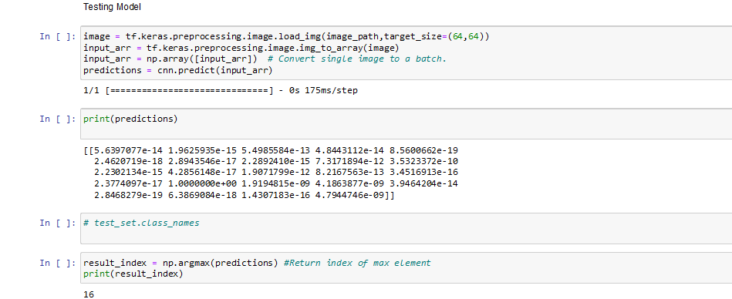

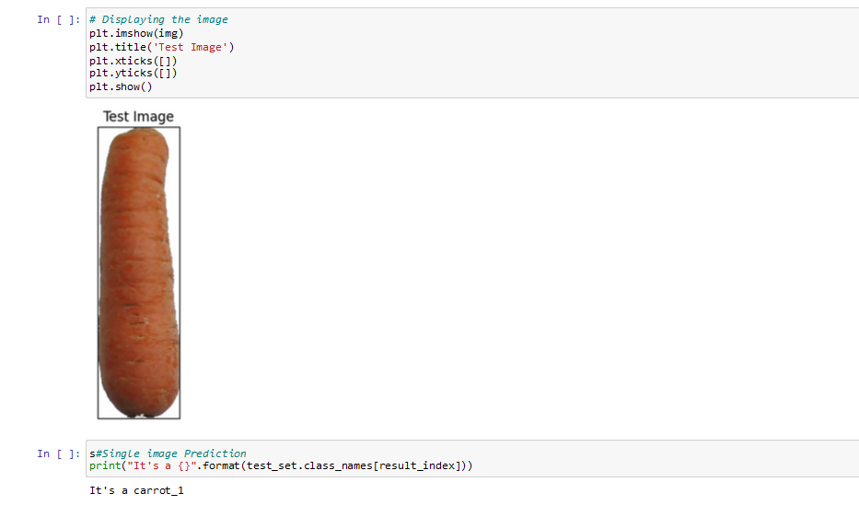

CODE LINK: <https://colab.research.google.com/drive/1k3o6ob3D1EC83ubymDWpSowqqkJ_haXC?usp=sharing>

GITHUB LINK: [DhanshreeRajput/Fruit-Recognition-System (github.com)](https://github.com/DhanshreeRajput/Fruit-Recognition-System)